Elton, Gruber, Brown, and Goetzmann
Modern Portfolio Theory and Investment Analysis, 9th Edition
Solutions to Text Problems: Chapter 18

Chapter 18: Problem 1

Since the company’s growth rate of 10% extends into the future indefinitely, use the constant-growth model to value its stock:

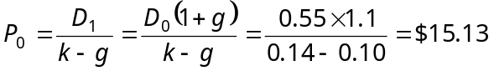

Chapter 18: Problem 2

Using equation (18.5b) in the text, we have:

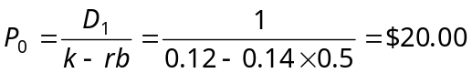

Chapter 18: Problem 3

Solving equation (18.5b) in the text for k (the required rate of return) we have:

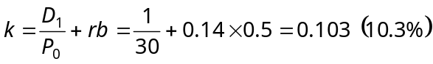

Chapter 18: Problem 4

Solving equation (18.5b) in the text for r (the rate of return on new investment) we have:
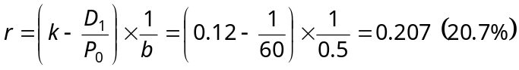

So the rate of return on new investment would have to change from 14% to 20.7%, an increase of 6.7 percentage points.

Chapter 18: Problem 5

This problem can be solved using the two-period growth model shown in the text, where the first growth period is 5 years with a growth rate of 10% (g₁) followed by a growth rate of 6% (g₂) indefinitely:

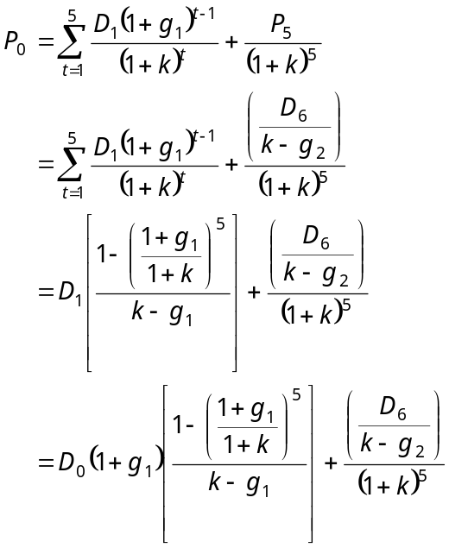

Recognizing that the dividend at the end of period 6 is equal to the dividend at the end of period 5 compounded 1 period at g₂ and then adjusted by a factor of 0.5/0.3 to reflect the increased dividend payout rate, we have:

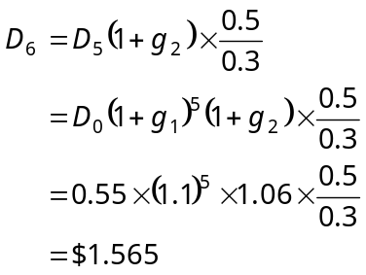

So we have:

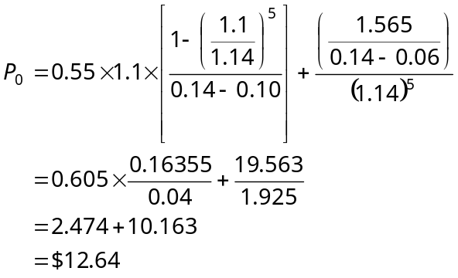

Chapter 18: Problem 6

This problem can be solved using the three-period growth model shown in the text, where the first growth period is 5 years with a growth rate of 10% (g₁) followed each year by linearly declining growth rates (g₂, g₃, g₄ and g₅) over a second period of 4 years down to a 6% steady-state growth rate (g_{s}) indefinitely thereafter. Since the growth rate is declining linearly over the 4-year period, the annual decline is 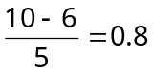 percentage points per year. So we have g₁ = 10% (first 5 years), g₂ = 9.2% (year 6), g₃ = 8.4% (year 7), g₄ = 7.6% (year 8), g₅ = 6.8% (year 9) and g_{S} = 6% (year 10 and thereafter), and the model is:

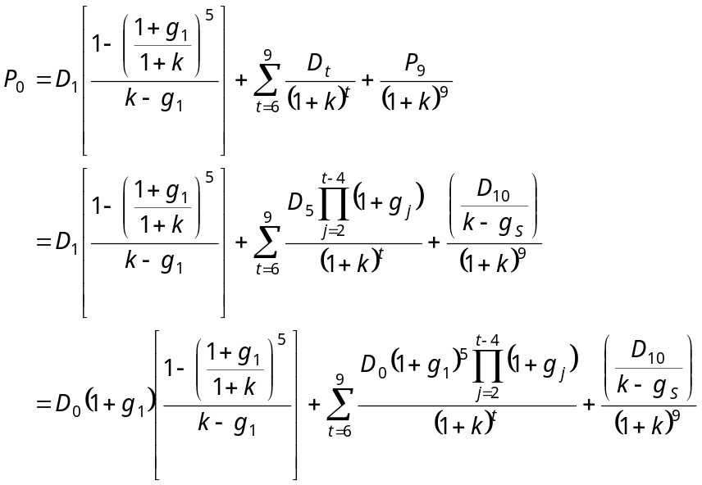

Recognizing that the dividend at the end of period 10 is equal to the dividend at the end of period 9 compounded 1 period at g_{S} and then adjusted by a factor of 0.5/0.3 to reflect the increased dividend payout rate, we have:

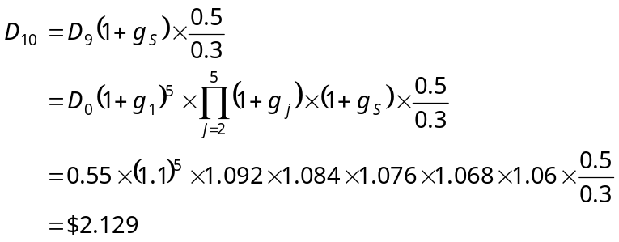

So we have:

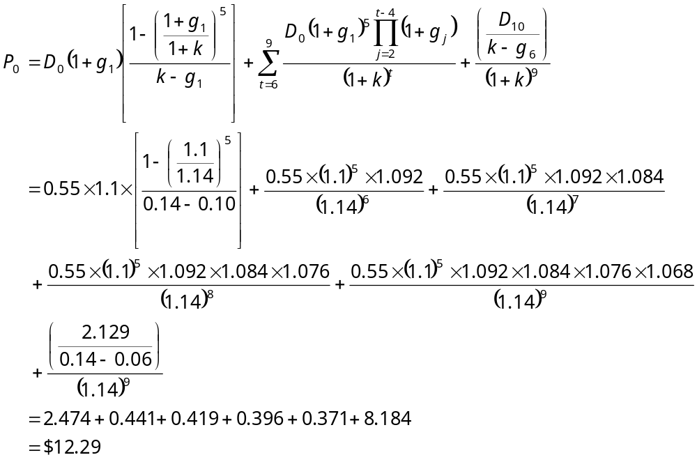

Chapter 18: Problem 7

Solving equation (18.5b) in the text for k (the expected rate of return) we have:

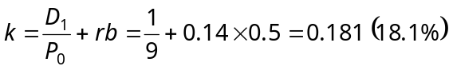

Chapter 18: Problem 8

Since the company’s growth rate of 10% extends into the future indefinitely, use the equation (18.6) in the text from the constant-growth model:

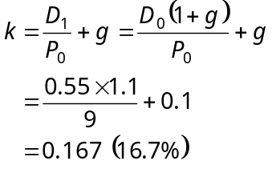

Chapter 18: Problem 9

This problem can be solved using the two-period growth model shown in the text, where the first growth period is 10 years with a growth rate of rb = g₁ followed by a growth rate of 5% (g₂) indefinitely. The model is:

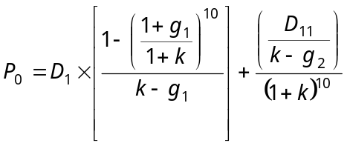

Given r = 0.14 and b = 0.5, g₁ = 0.14 × 0.5 = 0.07 (7%). Also,

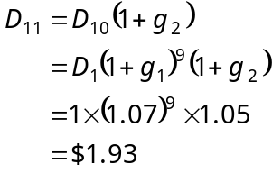
So we have:

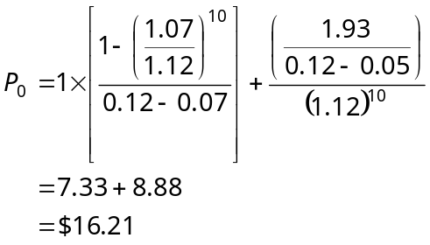

Chapter 18: Problem 10

This problem can be solved iteratively by substituting various values for k into the first formula shown in the answer for Problem 9. By trial and error the solution is
k = 9.6%.

Chapter 18: Problem 11

As with Problem 10, this problem can be solved iteratively by substituting various values for the length of the first growth period into the first formula shown in the answer for Problem 9. By trial and error the solution is 24 years.

Chapter 18: Problem 12

The solution to this problem is a general form of the model shown in the answer to Problem 6:

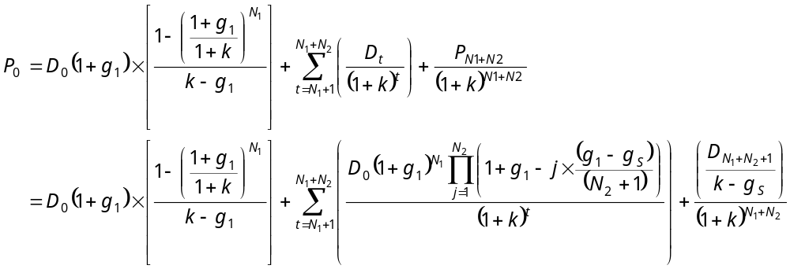
where

D₀ = the just-paid dividend

g₁ = the annual growth rate during the first period of years

N₁ = the number of years in the first growth period

N₂ = the number of years in the second growth period of linearly changing growth rates

g_{S} = the annual steady-state growth rate after the second period of linearly changing growth rates

Note that the step value for linearly changing rates from g₁ to g_{S} is
(g₁ − g_{S}) / (N₂ + 1), not (g₁ − g_{S}) / N₂.

